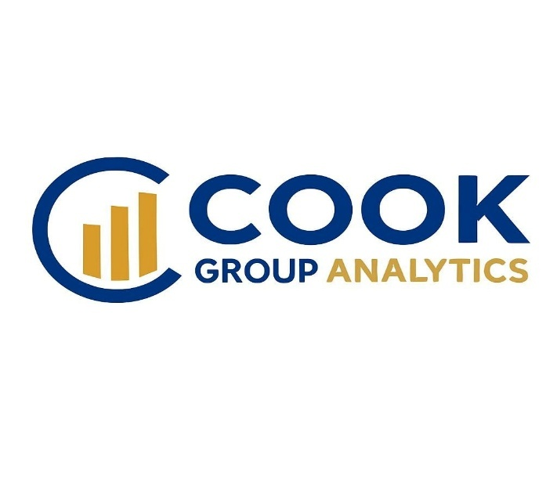

Business Plan

By Cook Group Analytics
February 2026

Kerryann Cook | kcook@cookgrouplegal.com | 845-270-0902
Kevin Hannemann | khannemann@cookgrouplegal.com | 646-508-5066

Table of Contents

Executive Summary 2
About Us 6
The Team 6
The Product 9
The Market 10
Competitive Edge and Differentiation 10
Business Model 11
Marketing Plan 11
Financial Plan 12

Executive Summary

About Us
Cook Group Analytics (“CGA”) is a continuing step along The Cook Group Law Firm’s (“TCG’s”) quest to reshape how mass tort claims are litigated and managed. The purpose of the company is first and foremost to bring our purpose-built internal software, The Cook Book (“TCB”), to market for use by the entire defense bar. During the last six years, with over one million separate billable time entries sent to clients, TCG has both developed and found the best, most efficient uses for TCB. Not only has this software allowed attorneys and staff at TCG to work far more efficiently, spending more of their time and mental energy directly solving legal problems for clients, but the law firm has seen tremendous, immediate cost savings – particularly in the finance and administrative departments. Our clients and their insurance partners have also found TCB to be a game-changing step up in both efficiency and accuracy of reporting and case management. The Cook Book provides tangible gains from improved efficiency for all parties involved in the mass tort space – except, of course, plaintiffs and their attorneys.
Our Product
The Cook Book was developed as a solution for mass tort defense law firms needing to utilize multiple different off-the-shelf software platforms in their operations. Programs like Juris or Timeslips allowed attorneys to enter their billable time and send in PDF format to clients and insurers. Worldox was used for internal document management, and external software like Claro or KCIC dashboards were used to share case management data internally and with clients. When interviewing potential CTOs while forming The Cook Group in 2020, Kerryann Cookgrew wary of candidates repeatedly recommending the same licenses for the same mediocre products as the solution to the complex demands of mass tort litigation All the products shared the same inability to handle insurance splits, a core need in every aspect of mass torts. And each product was built on a separate database, so the only method of transferring data between the systems was through manual import of PDF or Excel files. The Cook Book was built by The Cook Group Law Firm to wholistically address the technological needs of a high-level mass torts firm. No other available system begins to address the complex challenges involved in defending mass tort claims.

The Market

This business plan focuses on the asbestos litigation market only. Further development into the broader mass tort space is planned, but both market conditions and CGA’s position in the market dictate a singular focus on asbestos during the first phase of growth.
The asbestos litigation is the longest running mass tort in history. For over 50 years, case law and agile market participants have turned organic legal matters into a self-contained business market. This litigation is now a monetary transfer scheme from defendants and their insurers to plaintiffs’ counsel. The insurers invest their asbestos reserves and make a profit. The plaintiff firms get rich. Over the years, a balance between the two sides has developed. For the past 20 years, spending on asbestos litigation has been essentially frozen. Market reports consistently note that $1B is spent annually on payments to plaintiffs, and $1B is spent annually on defense counsel to defend those claims. These payments have remained consistent despite the obvious drop-off in actual asbestos exposures since it was largely banned in 1989 – demonstrating a decoupling from the underlying legal proceedings.
This tacit agreement between litigants has fossilized the defense market for asbestos litigation. The same law firms continue to defend asbestos claims, even as the roster of defendants constantly changes. Not only is the monetary value of the market consistent and predictable, but the potential law firm users of TCB will remain essentially unchanged over time. This unique market structure in the asbestos litigation means there is a detailed roadmap for increasing the number of users. Furthermore, as CGA scales, incremental costs will continue to drop. A higher and higher percentage of law firms in the litigation will be using TCB. Adding additional client/defendants then becomes a matter of changing permissions within an already-running platform, rather than full deployment of a new system for each new client acquisition.
Business Opportunity

The software used to manage and defend mass tort claims has evolved from other, pre-existing software used in other types of litigation. As detailed above, mass tort claims, and especially asbestos claims, are wholly unique from other types of legal matters. In many ways, running a mass tort defense law firm is more similar to running a bankruptcy claims trust than to an intellectual property or tax law firm. Technology solutions developed for more traditional legal claims are wholly inadequate.
The fundamental difference between mass tort legal claims and traditional litigation is the number of parties to each lawsuit. While most legal cases involve a single plaintiff vs. a single defendant, mass tort claims involve a single or multiple plaintiffs vs. a massive number of defendants (hence the name “mass tort”).

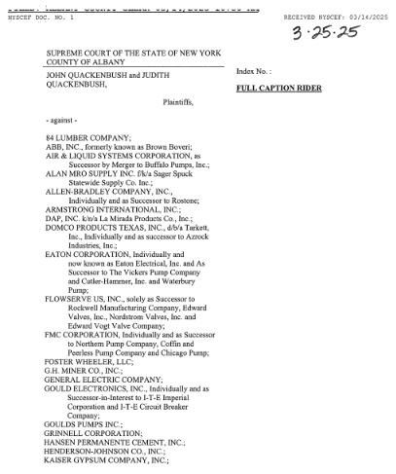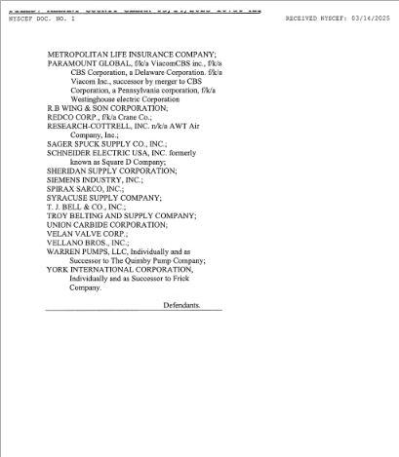

This complaint names 38 defendants.
This difference is further complicated by the historical and long-ranging insurance coverage available for asbestos claims. Because exposure dates often span many years, there can be a corresponding number of insurance policies providing coverage to defendants.
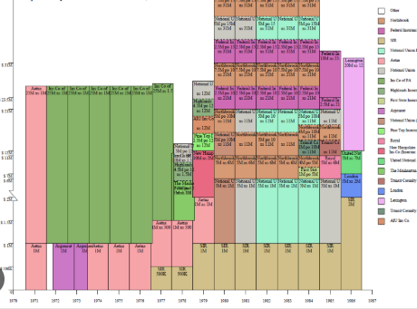
A typical insurance coverage chart
This dynamic creates exponential growth in case complexity. If one plaintiff sues 20 defendants, and each of those defendants has five different responsive insurance policies – then each law suit results in payments from 100 different insurance entities. This complexity affects almost every aspect of defending and managing mass tort claims. It also means that other legal software can only address specific needs within firms, rather than being comprehensive solutions.
Broadly, legal software can be broken down into three categories. Billing, internal case management, and document management. In typical litigation matters, where cases involve simply a single plaintiff vs. a single defendant, coordinating data between these three system types is elementary. All that is required is to match plaintiffs and defendants within the systems. Conversely, in mass tort claims, each of these systems deals with a different layer of complexity within the lawsuit. Internal case management software is set up to view individual plaintiffs. The various defendants sued by each plaintiff are data fields that correspond to each plaintiff, rather than being a separate matter, and which insurance policies are responsive to each claim is not accounted for. For lawyers entering their time into billing software, the matters are viewed as a single plaintiff vs. a single defendant. Each defendant in a plaintiff case is billed separately. And on the back end, when bills are sent to insurers for payments, matters are expressed in terms of individual insurance policies. Document management systems are organized by plaintiff bins, with data fields for defendants.
The Cook Book was meant to address this specific issue of complexity in litigation matters. Rather than having completely separate systems with completely different databases supporting them, everything is based on a single, unified organizational scheme. The billing, case management, and document management interfaces all sit on top of the same database. This allows all three systems to work in unison in a way that is impossible for other software. Additionally, it allows for integration with enterprise software like Microsoft Outlook. To be able to draft emails, make calendar entries, initiate workflows, send bills, and track data from a single unified group of matters has provided massive efficiency gains in both litigation and administration costs at all levels of The Cook Group.
While in many industries, having a purpose-built software platform that addresses niche business needs would be enough to bring The Cook Book to market. The legal industry can be set in their ways. If something is working in court for their client, there is no need to change it. This caution carries over to technology implementation. Traditionally law firms have been slow to adapt to new technology or software. However, the current interest in AI has pushed many firms to take a second look at the software they are running. Unlike many past technology shifts, AI cannot simply be bolted onto existing software. The Cook Book has AI integrated at all levels from automation to analysis, so we are well positioned to fulfill this new demand being put on law firms by their clients. Further reducing the traditional “stickiness” in the asbestos software market is the fact that Worldox, the standard document management system for asbestos law firms, has ended support for their old product and are forcing customers into a far more expensive version. This too is causing asbestos law firms to take a second look at their software platforms and will provide a significant initial boost in our marketing efforts.

About Us

Our Vision
Cook Group Analytics’ vision is to provide the most modern and well-thought-out data and technology platforms for anyone involved in the defense of mass tort claims. We aim to use technology to balance the playing field in an area of the law that is clearly biased against defendants. TCB was built specifically to address inefficiencies in billing and case management at the law firm level. As CGA grows, we hope to provide solutions at all levels that wholistically address the niche issues in the mass tort space.

The Team

We have spent six years building a machine that chews up asbestos cases with the precision of a Swiss watch.
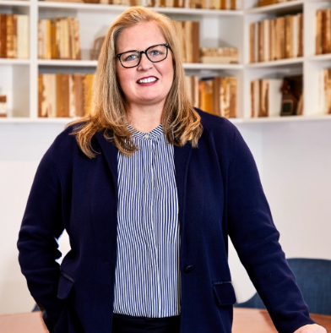 Kerryann Cook - Co-Founder and Executive Director

Kerryann Cook is the Managing Partner and founding member of The Cook Group. As one of the premier products liability defense attorneys in the United States, Kerryann has managed, tried or resolved thousands of cases across the country. From that experience, Kerryann has seen the common pitfalls for clients navigating lawsuits, as well as some of the shortcomings that can happen in client service. Kerryann believes there is a more modern, more efficient and more effective way to practice law and service clients. That is why she founded The Cook Group with her handpicked team of attorneys dedicated to leading the charge to modernize and streamline practices to more efficiently serve clients while effectively advancing and protecting their interests.

Known as an extremely tough and shrewd advocate and negotiator, Kerryann was chosen by her peers to currently serve as one of four defense liaison counsel to the New York City Asbestos Litigation (NYCAL). She has also served as a member of the NYCAL Case Management Committee, is liaison counsel for active docket cases, and is also a member of the defense medical liaison group.

Due to her proven track record of successfully managing and settling cases across the country, Kerryann serves as National Coordinating Counsel for several major clients in toxic tort litigation around the nation. In addition to managing and resolving cases for clients, Kerryann has played an instrumental role in bringing important legal issues to the forefront for her clients on the appellate side as well. Some of her appellate highlights include Corazza v. Amchem Prods. Inc., (Cooney (2019 WL 1387270)(reversing $1.7 million asbestos exposure award because Plaintiff failed to show that he was exposed to asbestos through his work on Caterpillar equipment) and Robert F. Perdicaro v. A.O. Smith Water Products, et al., 52 A.D.3d 300 (1st Dep’t 2008). Kerryann is in demand on the public speaking circuit and has served on the faculty at industry conferences presented by the American Conference Institute (ACI), Defense Resource Institute (DRI), Harris Martin, and Perrin Conferences. She has also given presentations on a wide variety of legal issues for numerous insurance companies as a part of their in-house training programs.
 Kevin Hannemann – Co-Founder and CEO

Prior to The Cook Group, Kevin spent five years at two of the largest long-tail reinsurance providers in the world, focused on strategic risk management across multiple books of business. Through comprehensive litigation management – including retention of outside counsel, trial risk and strategy, granular case risk assessment and valuation, training of both in-house personnel and outside counsel on a variety of legal issues, development of quantitative risk measurement tools, direct negotiation with stake-holders, and frequent collaboration with policyholder clients – Kevin was able to help pay over $500,000,000.00 to more than 10,000 claimants in all 50 states, while also appropriately conserving valuable policyholder client insurance assets.

At The Cook Group, Kevin uses his broad and deep litigation management experience to provide clients with efficient and aggressive management of individual cases and entire liability portfolios. Knowing when to quietly resolve and when to litigate, or even try a case through verdict and appeal, is the most difficult decision of any case. Kevin’s expertise helps clients and insurers feel confident in their decisions.

Kevin has been a panelist or moderator at numerous industry conferences around the country including Perrin Conferences, Defense Research Institute, Defense Asbestos Litigation Seminar, and the Claims and Litigation Management Alliance covering the insurer perspective on asbestos litigation, settlement and negotiation strategies, and issues with the New York City Asbestos Litigation (NYCAL) discovery process.
 Noah Oliphant - Co-Founder and CTO

Noah Oliphant serves as Chief Technology Officer and Chief Information Officer for The Cook Group. He has worked in IT for over 20 years and has deep expertise in a wide range of technologies including Cloud Computing, Cloud Infrastructure, Security, Compliance, System Integration, and Custom Software Development.

Noah worked closely with other employees at The Cook Group to design and implement a custom and proprietary Workflow Application that includes modules for Matter Intake, Document Discovery and Full Text Search, Matter Management, Settlement Tracking, Trial Management, Billing, Invoicing, and other operational functions.His focus is providing modern, efficient, and secure technology solutions to The Cook Group.
 Campbell Rankin - Co-Founder and CFO

Campbell Rankin serves as Chief Financial Officer for The Cook Group New York office. He has worked in Finance and Commercial Real Estate for over 20 years and is excited to bring that expertise to Cook Group Analytics.

As an integral part of founding The Cook Group, Campbell organized the development of technology systems, establishing policies and procedures, securing insurance, securing Real Estate, and managing operations.

Campbell continues to run all non-legal functions, managing billing, AP, finance, real estate, collections, and payroll. His focus is driving efficiency and supporting the world class legal representation The Cook Group provides.

The Product

The guiding principle in designing The Cook Book was ease of use for attorneys. The volume of cases handled by a mass tort defense firm is an order of magnitude greater than what traditional law firms deal with. As a result, every mouse-click, every additional computer window, every new document search becomes that much more important when trying to operate efficiently. Every resource that an attorney would need to intake, manage, litigate, and bill one or many claims is available in one place.

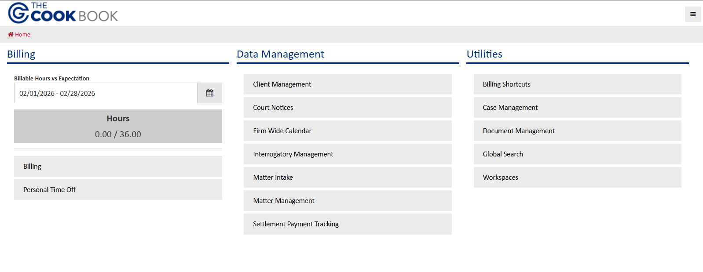
Attorney Dashboard
Due to the underlying organizational structure, each component is integrated with the other. For example, the case management screen below has direct access to the calendar (depositions, court appearances, etc.), billing (time entry), and documents (interrogatories). This seamless transition between the various tasks needed to manage claims makes every task faster and more accurate.
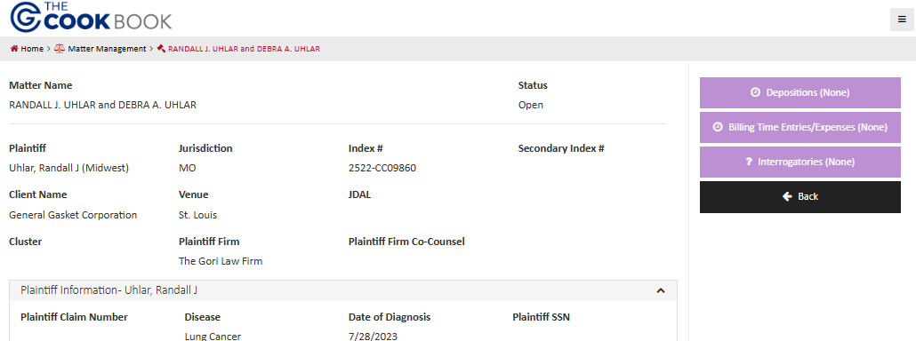
All systems work together

The Market

The Cook Book has no true competition. Every other piece of legal software available on the market was made first with traditional cases in mind and then adapted to mass tort litigation. There is no single solution to the complex needs of a law firm defending mass tort claims. The Cook Book was born from this glaring hole. Our software’s purpose-built nature not only allows for massive efficiency gains in our legal defense and law firm operations but also addresses the unique issue of passed-on costs in the asbestos litigation. As detailed above, the insurers and defense firms involved in asbestos litigation remain largely unchanged over time, even while the companies being defended changes. That means that passed-on costs from defense firms are wholly assumed by asbestos insurers, rather than spread out across multiple different litigation areas. The inefficiencies of having to use three separate software programs is too opaque to be observed in normal litigation. But in asbestos litigation, that triple-charging for software becomes patently obvious. The Cook Book addresses that redundancy while also making each separate software type more functional.

Competitive Edge and Differentiation

The Cook Book provides a clear value-proposition for law firms. Rather than paying for three pieces of software to defend and manage their mass tort claims, law firms will be able to rely on The Cook Book alone.

 | Juris | Timeslips | Worldox | Claro | KCIC | The Cook Book
Billing | ✓ | ✓ | X | X | X | ✓
Document Management | X | X | ✓ | X | X | ✓
Case Management | X | X | X | ✓ | ✓ | ✓
Interface with payment systems | PDF upload | PDF upload | PDF upload | PDF upload | PDF upload | Direct
Interface with Court dockets | Manual web search | Manual web search | Manual web search | Manual web search | Manual web search | Direct

Business Model

CGA’s business model is centered around the complex flows of money within the asbestos litigation. While the broad functioning of the asbestos litigation is to move funds from insurance companies to defense firms to plaintiffs, the individual defendants and insurance policies are the pathway through which this money must necessarily flow. This means that while the software was designed to be used by attorneys and law firms, it must additionally produce significant and measurable gains to individual client/defendants. We plan on offering two different versions of The Cook Book to address this dislocation. A version centered around billing will give immediate gains to law firms in their finance and administrative budgets. The full enterprise version of the software will be marketed to defendants and insurers, allowing them full control over the defense of their claims. This two-tiered approach will pay gains as we increase market share. More law firms and defendants will already be using The Cook Book so the implementation and marketing costs will decline as market share increases.

Marketing Plan

Marketing of The Cook Book is similarly specific to asbestos litigation. The closed world of market participants means that marketing efforts can be hyper-focused. Initial sales will be handled by Kevin Hannemann and another former insurance executive. Together they have over 30 years of networking in the asbestos industry. Rather than hiring a sales force to cold call clients, we will be working with a known client list with past connections to CGA. More broad-based marketing efforts will be focused on industry conferences such as Perrin or DRI. These conferences gather essentially all market participants in one room, so they will be the most productive forms of mass marketing available to us.

Financial Plan

Overview:

This financial plan is specifically tailored to gaining market share in the asbestos litigation. CGA’s unique business relationship with The Cook Group Law Firm allows for a significantly different cost structure than other, stand-alone companies. In short, CGA is not a software startup, it is The Cook Group’s development and marketing arm for our internal software. Product testing has proceeded for six years under the normal operations of the law firm. Business operations will be fractional cost to law firm operations. No staff or expenses will be added until necessary. This nimbleness in scaling is a key part of The Cook Group Law Firm’s success and will allow CGA’s fixed costs to scale evenly as opposed to the lumpy spending required for other companies.
While a more traditional financial approach will be required when expanding into the broader mass tort or insurance markets, CGA’s expansion in the asbestos market will proceed along the same lines as that of the law firm. Efficiency and nimbleness will guide all decisions. Entry into the broader mass tort market will require some tweaking of the software as well as an updated business and financial plan. While the differences between other mass torts and asbestos litigation are relatively minor, those nuances are where the value lies in CGA. The Cook Book was designed specifically to deal with asbestos litigation and solves the underlying issues elegantly. In order to bring a similarly valuable product to market to manage other mass tort claims, it is critical that CGA works hand in hand with TCG’s attorneys as the law firm’s client list grows to include other MDL and mass tort defendants. We seek to bring purpose-built software to market, not adaptations of off-the-shelf solutions.

Revenue

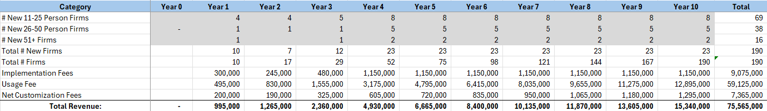

Expenses

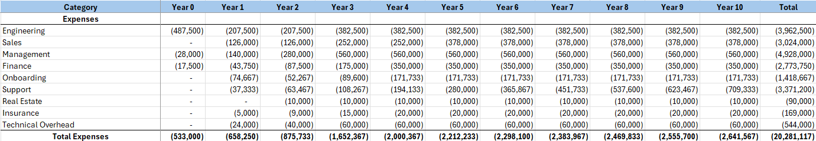

Both the revenue and expense models above reflect our vision for gaining market share in the asbestos litigation (initial boost from market demand, then a steady increase), and our efficient corporate and business structure.

Conclusion

Because of the hyper-focused customization of The Cook Book for the insular and unique world of asbestos litigation, Cook Group Analytics offers singular value as an entry point into a traditionally closed market, providing a rock-solid foundation to expand into other, larger markets.

